Next S.T.E.P. Café is Open for Business

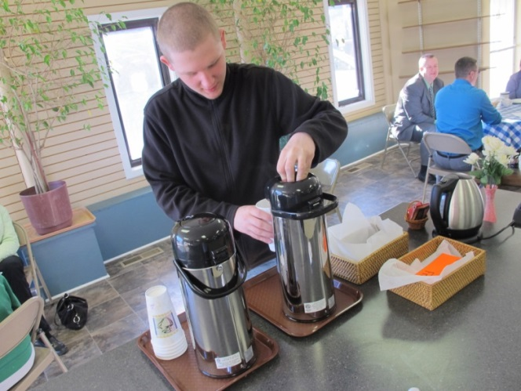
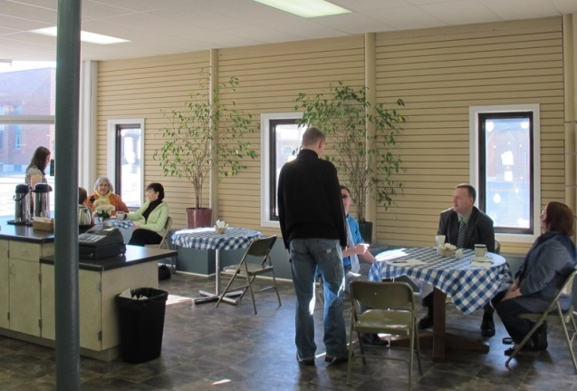
The SMEC students at the Next S.T.E.P. Transition program have finally opened the doors to their café. April 8th was the opening day for the public to come in and have a refreshing cup of coffee or try a tasty morning pastry. The students at the program have been working on their café project for many months. They were set with a task to brainstorm an idea for a business that they could run from the store front of the building. These juniors and sophomores began creating their business plan in November and presented their plan to members of the school board back in February. The students created long and short term goals for their business, contacted local newspapers inquiring about advertising costs, and researched prices for items needed to run their café. They have spent the last month budgeting, ordering, and preparing the building for their new endeavor and were excited to finally be open and serving the community. Along with coffee and pastries the store will be selling Rebel gear and Southland Arts t-shirts for the school district.
This is the just the first of many business opportunities that the Next S.T.E.P. program hopes to provide to the public. As the program matures, the site will be used to sell student manufactured merchandise and services. The students will utilize the retail shelves and store windows to display their items and services. The program is designed for high school and 18-21 year old students to access job experiences. Student talents and work skills are assessed and they have an opportunity to learn how to work in a safe environment prior to going into the community. Students also practice life skills and learn how to act appropriately for work.
Menu
Bagel $2.25
English Muffin $2.25
Small pastry $.50
Milk $1.00
Coffee $1.00
Coffee to Go $1.25
Iced Coffee $1.00
Orange Juice $1.00
Hot Tea $1.00

The Next S.T.E.P. Café is located in the old Adam’s Drug Store building on Highway 56 across from Corky’s gas station. The coffee shop is open from 8:00am to 10:00 am on school days only. For more information call 507-582-7798. Please stop in to support our students and their new business! We are still accepting free-will donations and are looking for chairs to furnish our storefront. Gift cards are available to purchase for $10 for items in the café only. The building is open from 8:00am to 3:00pm to except donations and to provide tours of the facility.

